Use-Case Realization Report (Analysis)
Display Survey List

Issue 1.0
Revision History
Date | Issue | Description | Author
01/Aug/09 | 1.0 | First Issue | Thomas Yap

Table of Contents
1. Brief Description 4
2. Flow of Events 4
2.1 Standard Flow 4
2.1.1 Display Survey List 4
2.2 Exception 4
3. Interaction Diagrams 5
3.1 Collaboration Diagram for Display Survey List 5
4. Participating Objects 5
5. Class Diagrams 6
5.1 Class Diagram for Display Survey List 6
6. Derived Requirements 6

Use-Case Realization Report
Display Survey List

Brief Description
This use case enables the controller to display survey list retrieve from Survey Pool. It involves displaying the menu and form and search by title list to display the details.

Flow of Events
The standard flow of events for this use case and any exceptions are described in the following subsections. The events are described in terms of Actors and Analysis Objects.

Standard Flow
This use case covers the Survey Maintenance - Display Survey List. The standard flow of these events are described below.

Display Survey List
The running of the application is shown in section 3.1. The flow of event is as follow:

- When the application start, the first operation to be performed is the startup operation of the main controller. This operation will create all the control objects and the entity objects necessary for operation Display Survey List:
  - The control object created is: Survey Controller
  - The entity objects create are: Survey Table and Transaction Record

- The main controller will start the main function menu:
  - To start Display Survey List, operation FormDisplaySurvey is activated by Survey Controller to display a Survey form.
  - Portal Admin then activate the search by retrieving title list of Survey record.
  - A searchstring can also be entered for filtering and speed up the title list search.The FormDisplaySurvey will validate the searchstring using validate operation. Then Survey Controller will check for additional criteria if any. If no record found, Survey Controller will send a error message to FormDisplaySurvey Interface.
  - After the record is found, the title list will be displayed on FormDisplaySurvey.
  - A transaction log will be created by operation createActivity and store in entity TransactionRecord.

- Step 2 will be repeated until all searches are completed. Then controller will terminate the application by issuing operation close.

Exception
None.

Interaction Diagrams

Collaboration Diagram for Display Survey List
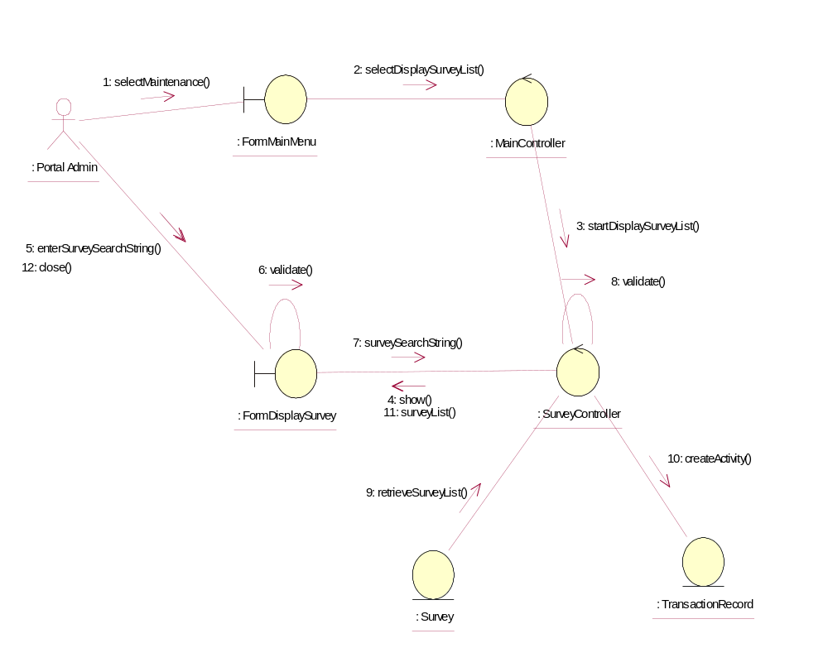

Participating Objects
: FormDisplaySurvey
This object is the interface for keying Surveys details.

: FormMainMenu
This is the main menu at the beginning of the application from where it can access the Survey Maintenance - Display Survey List operation.

: MainController
This is the main controller that control the whole system.

: Portal Admin
This is the only actor that authorized to perform operation Survey Maintenance - Display Survey List.

: Survey
This entity stores all the exam or exercise Surveys.

: SurveyController
This is the controller for Survey Maintenance. It creates and activates FormDisplaySurvey interface and Survey entity object.

: TransactionRecord
This is the entity object that created for transaction log and audit trail.

Class Diagrams

Class Diagram for Display Survey List
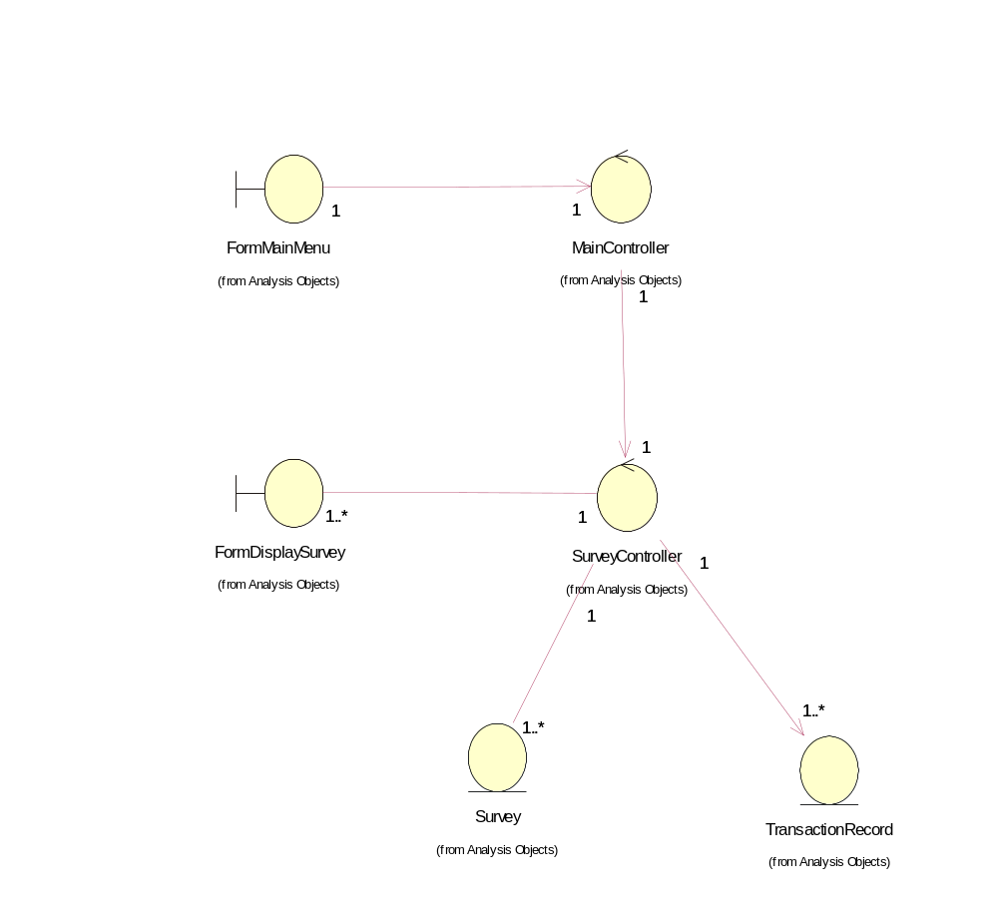

Derived Requirements
The FormMainMenu and FormDisplaySurvey Interface should have the format specified in User Requirements Specification for Content Management Portal.

